IFT 266 Introduction to Network Information Communication Technology (ICT)
Lab 8
Switch configuration (Console Connection)

After you complete each step, put an ‘x’ in the completed box
Part A; Connect to a physical switch using a console cable via a PC.
(This part of the lab is to provide you with information only. You set up a console connection in Part B using packet tracer)
We will setup a console line into this switch so we can configure the switch via a console cable (initial switch configuration).

Console port/interface is the primary interface for initial configuration, monitoring, troubleshooting and disaster recovery procedures of a Cisco router or switch.

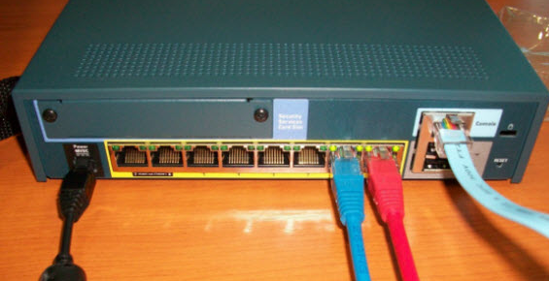
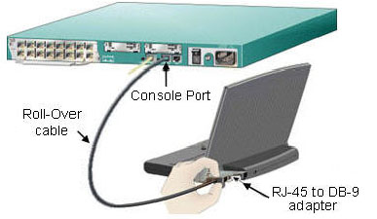

Physical Connection
Connect the PC via a rollover/console cable to the switch
RJ-45 connection into the console port/interface on the switch
DB9 connection via adapter in PC
Most PC’s will not have serial ports so need to get USB adapter. Nowadays there is a USB console cable (no longer have to use management station with DB9 serial connector or adapter)

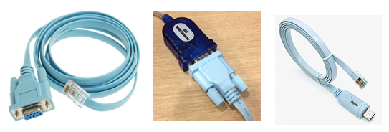

After the PC is physically connected to the console port, Terminal emulator software package (e.g. Putty or free terminal emulator software) must be installed and configured on the PC. Terminal emulator treats all data as text. It accepts the text typed by the user and sends it over the console connection to the switch.
Similarly, any bits coming into the PC over the console connection are displayed as text for the user to read
Emulator must be configured to use the PC’s serial port to match the settings on the switch’s console port settings
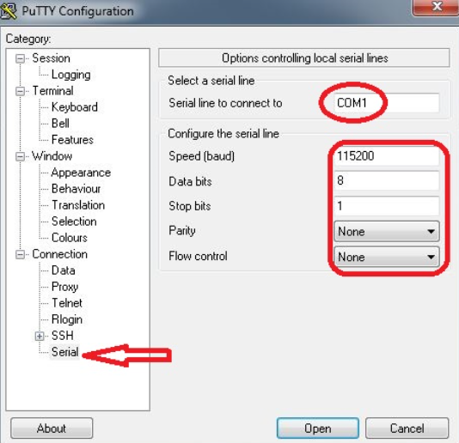


Now we understand how we set the connection up on a physical PC, let us do it in packet tracer

Part B: Setup a console connection in packet tracer
- Open up the Packet File that you saved from Lab 4 (you would have used the same file for labs 5, 6 and 7)

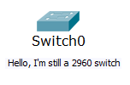

- Type the following commands into the switch. Make sure you exit all the way back to user mode.
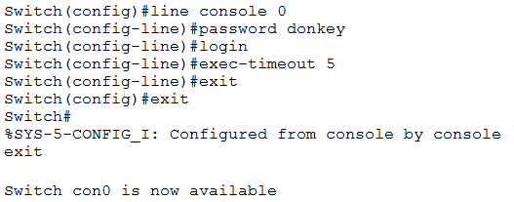

- To set the console line we use the command line console 0. All the lines start at zero and there is only one console port that you can physically plug into.
- The login command forces a login on the console line, so someone who plugs in a console cable, will then be required to enter the password in this case ‘donkey’.
- If the console connection becomes in-active for a certain period of time in this case 5 minutes, the exec-timeout command will be applied.

- Now you have setup up the console connection on the switch. We will now add a PC to our configuration. Use a console cable which will goes from the RS 232 port on the PC to the console port on the switch.

RS-232 serial port was once a standard feature of a personal computer, used for connections to modems, printers, mice, data storage, switches etc.

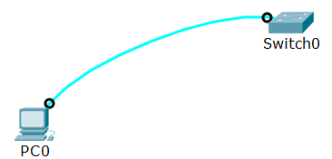
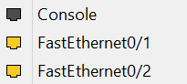

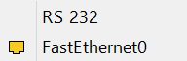

- Click on the PC and then the Desktop tab and then Terminal and the port configurations appears. Click ok and then you will be asked to enter the password ‘donkey’ that you applied to the console port. If this words correctly, you should now have access to the Switch command line.
